Question 1

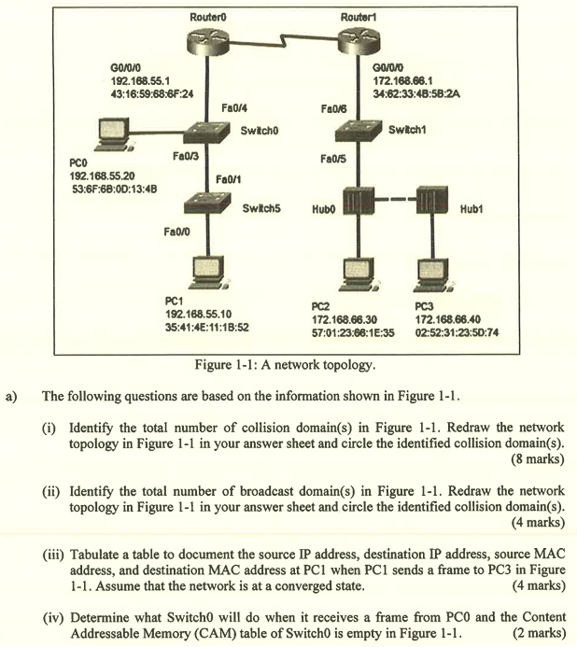
(i) 7 collision domains
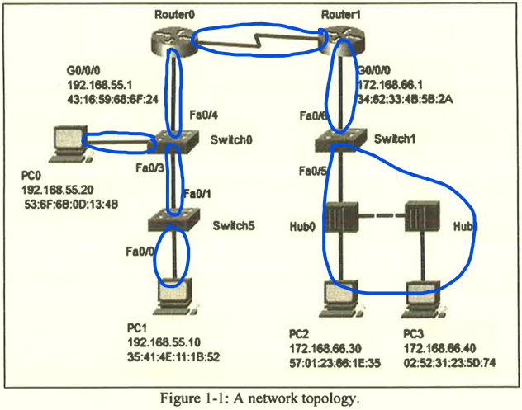

(ii) 3 broadcast domains
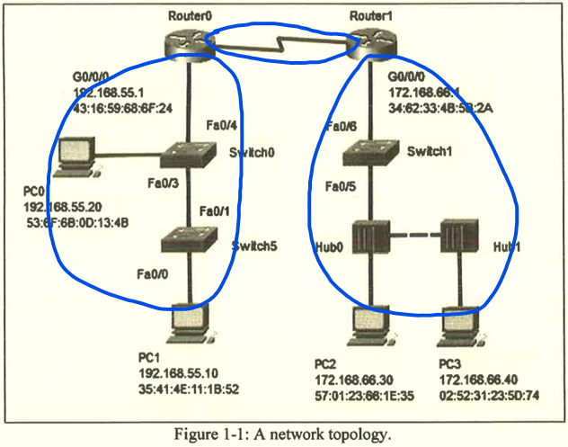

(iii)
Source IP Address | Destination IP Address | Source MAC Address | Destination MAC Address
192.168.55.10 | 172.168.66.40 | 35:41:4E:11:1B:52 | 43:16:59:68:6F:24

(iv)
- When Switch0 receives the frame, it will check whether the source MAC address of the frame exists in the Content Addressable Memory (CAM) table.
- Since the source MAC address does not exist in the CAM table, the switch will add this MAC address into the CAM table at port Fa0/3.
- Switch0 will also check whether the destination MAC address of the frame exists in the CAM table.
- Since the destination MAC address does not exist in the CAM table, the switch will forward the frame out all the available interfaces such as Fa0/3 and Fa0/4 except the ingress interface connected to PC0.

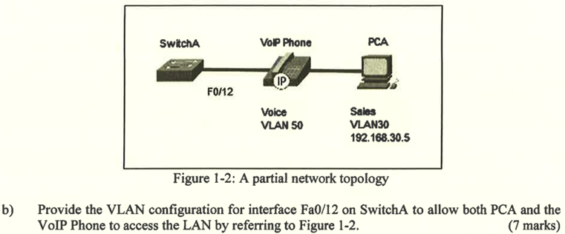
vlan 50
name Voice

vlan 30
name Sales

int fa0/12
switchport mode access
switchport voice vlan 50
switchport access vlan 30

Question 2

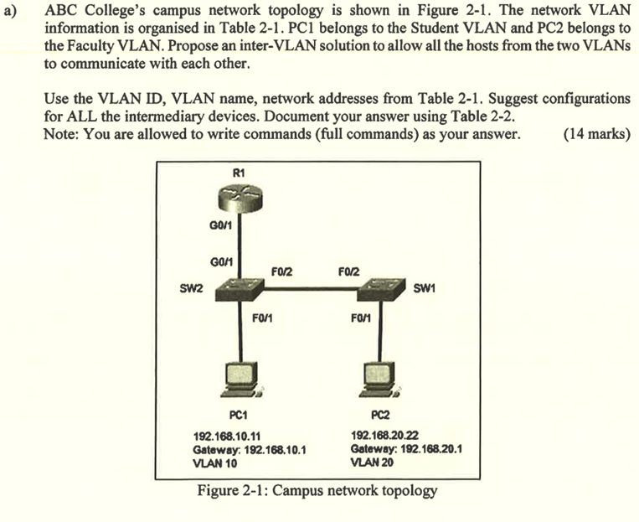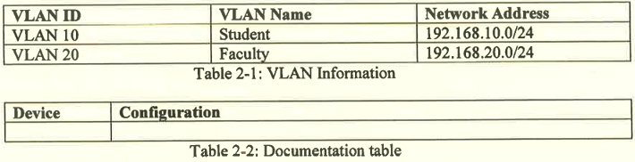
Device | Configuration
R1 | interface g0/1.10  encapsulation dot1q 10  ip address 192.168.10.1 255.255.255.0  interface g0/1.20  encapsulation dot1q 20  ip address 192.168.20.1 255.255.255.0  interface g0/1  no shutdown
SW1 | vlan 10  name Student  vlan 20  name Faculty  interface f0/1  switchport mode access  switchport access vlan 20  no shutdown  interface f0/2  switchport mode trunk  switchport trunk allowed vlan 10,20  no shutdown
SW2 | vlan 10  name Student  vlan 20  name Faculty  interface g0/1  switchport mode trunk  switchport trunk allowed vlan 10,20  no shutdown  interface f0/1  switchport mode access  switchport access vlan 10  no shutdown  interface f0/2  switchport mode trunk  switchport trunk allowed vlan 10,20  no shutdown

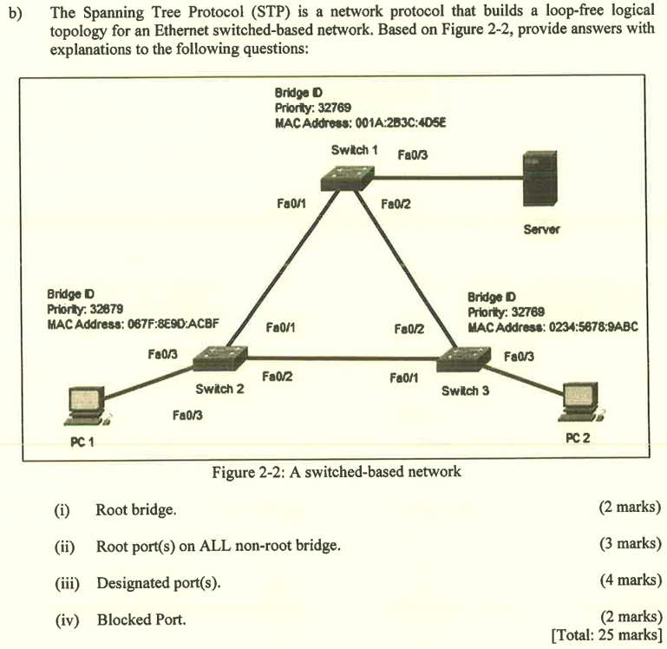
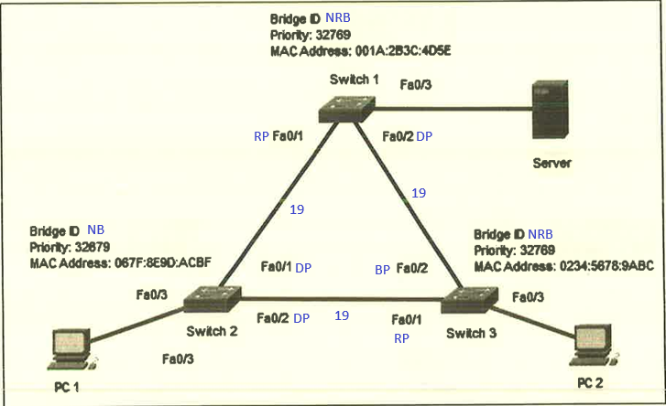
(i) Switch 2

(ii)
- Switch 1: Fa0/1
- Switch 3: Fa0/1

(iii)
- Switch 1: Fa0/2
- Switch 2: Fa0/1, Fa0/2

(iv) Switch 3: Fa0/2

Question 3

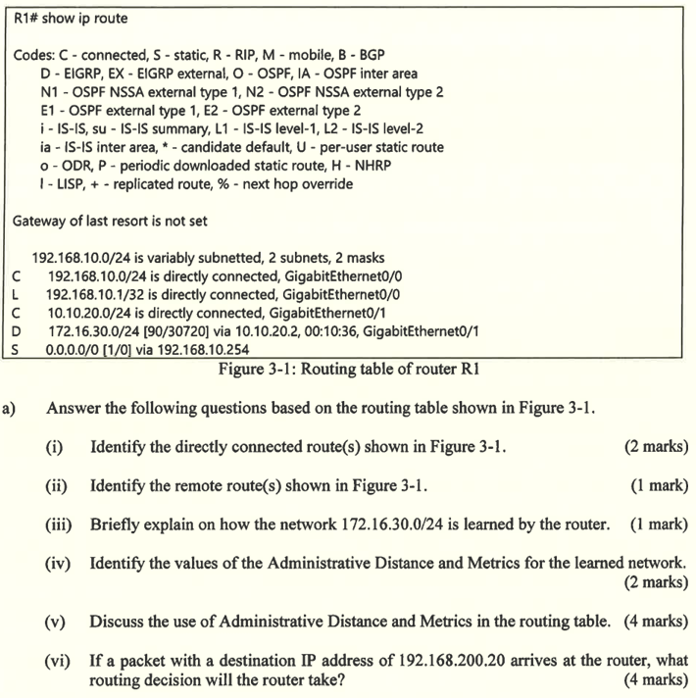
(i)
- 192.168.10.0/24
- 10.10.20.0/24

(ii) 172.16.30.0/24

(iii) The router can learn the remote network via dynamic routing protocol such as Enhanced Interior Gateway Routing Protocol (EIGRP).

(iv) Administrative Distance is 90 and Metrics is 30720.

(v)
- Administrative Distance is used to identify the trustworthiness of the route. The lower the Administrative Distance value, the higher the trustworthiness of the route.
- Metrics is used to identify the composite value calculated based on different factors such as load, reliability, delay and bandwidth.

(vi)
- The router will drop the packet.
- This is because the destination IP address 192.168.200.20 does not match any available route in the router's routing table.
- The gateway of last resort or default route is not configured, so there will be no next-hop router to forward the packet out of any interface.

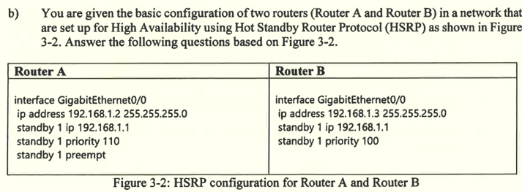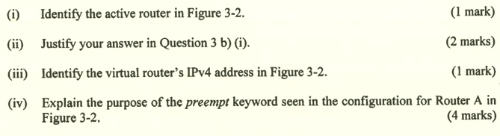
(i) Router A

(ii) Router A has higher HSRP priority compared to Router B.

(iii) 192.168.1.1

(iv)
- When the current active router (Router A) fails, Router B will take over the active router role of Router A to send hello messages.
- When Router A comes back online, the preempt feature will help to trigger the re-election process and let Router A take back the active router role since it has higher HSRP priority compared to Router B.

- EtherChannel is a technology that groups multiple physical Ethernet or Gigabit Ethernet ports into one logical channel.
- It will create a virtual interface (port-channel) after creating EtherChannel.
- It can effectively ensure the consistency of configurations on different individual ports. Most of the configuration tasks can be done on the EtherChannel interface, instead of configuring it on individual ports many times.

Question 4

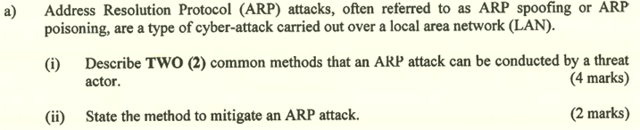
(i)
- When a hosts broadcast an ARP request to determine MAC address of hosts with destination IP address, the attackers may send a gratuitous ARP message to switch with spoofed MAC address.
- This causes the switch to update its MAC table accordingly.
- Then, the attackers also send an unsolicited ARP replies to the hosts with IP address of threat actor and default gateway ip address to create man-in-the-middle attacks.

(ii) Implement Dynamic ARP Inspection (DAI) on ports.

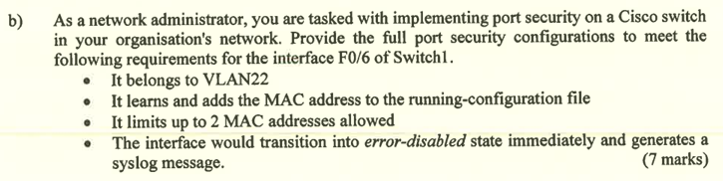
interface f0/6
switchport mode access
switchport access vlan 22
switchport port-security
switchport port-security mac-address sticky
switchport port-security maximum 2
switchport port-security violation shutdown

- Autonomous access points
  - It is standalone device configured through a command line interface or GUI.
  - Each autonomous access point acts independently of the others and is configured and managed manually by the administrator.
- Controller-based access points
  - It is also known as lightweight APs (LAPs).
  - It uses Lightweight Access Point Protocol (LWAPP) to communicate with a LWAN controller (WLC).
  - Each LAP is automatically configured and managed by the WLC.

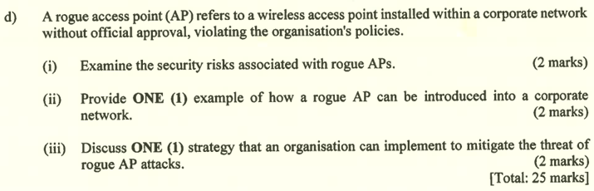
(i) The personal information of a client who is connected to the rogue access point may be captured or accessed by the threat actors.

(ii) Attackers introduce a rogue AP and configure it with a SSID same as the legitimate AP in public areas to masquerade as a legitimate AP for letting clients to connect to it.

(iii) Organizations can use monitoring software to detect the radio spectrum of unauthorized APs.

